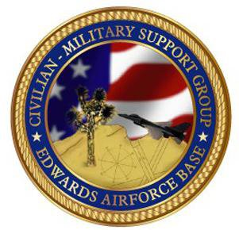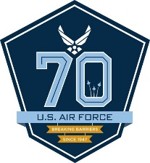

EDWARDS AFB CIVILIAN-MILITARY SUPPORT GROUP
AFMC Community Liaison Program
and
Installation of Directors and Officers
Dinner

Thursday, 12 October 2017
University of Antelope Valley Grand Ballroom
Lancaster, CA

SPONSORSHIPS AVAILABLE

The Edwards AFB Civilian-Military Support will be hosting a dinner event for Air Force Material Command Commander General Ellen Pawlikowski and representatives of AFMC’s Community Liaison Program from across the country as they visit Edwards AFB and our Antelope Valley. This event will also serve as the Civ-Mil Group’s annual Installation Dinner and Ceremony where the newest Directors and Officers will be inducted.

Sponsorships are available for this evening event. All sponsorships are $250. Included will be two seats to the event and public acknowledgement via the Civ-Mil website, event flyers, and the published program; also recognition during the evening’s festivities.

This is a great opportunity to meet senior Air Force Leadership, other Government officials, community partners from across the US, and local community leaders and business people.

Information and Sponsorship requests can be accessed via: www.eafbcivmil.org or by contacting Rhonda Nelson rhonda.nelson@ngc.com or Allen Hoffman allenhoffman34@gmail.com

The Edwards AFB Civilian-Military Support is a non-profit organization dedicated to supporting the Airmen, other Service Members, and their families at Edwards AFB and Air Force Plant 42.

